
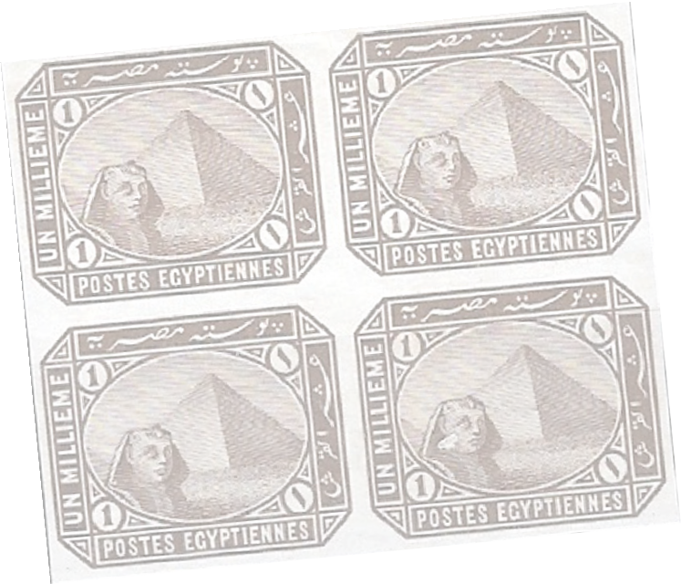
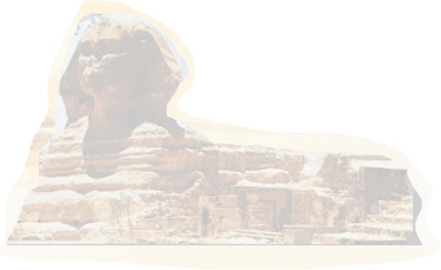
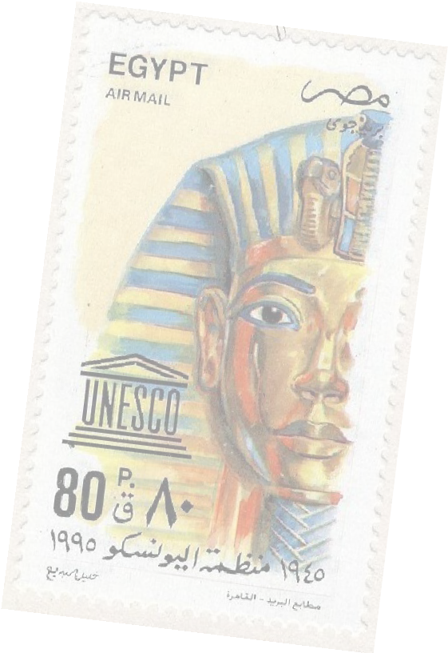
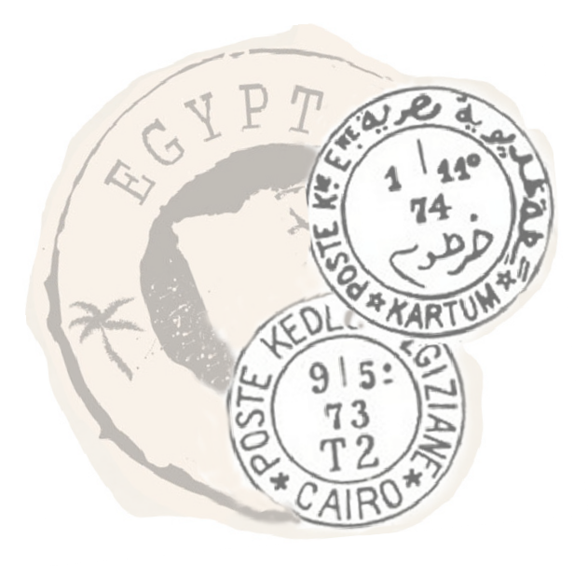


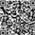
Membership Application

Send completed form to Dr. Ahmed Abouesh, Membership Secretary at Ahmed@Abouesh.com or P.O. Box ?? City, Ca zip code

Name Age Street Address City State/Province/Region Zip/Postal Code Country Cell E-mail
Under UK GDPR (2018), We do not share any data with third parties it is solely for membership administration.
PayPal to EgyptStudyCircle@hotmail.com GBP 17 EUR 19 US $24
Egypt Study Circle (ESC) members receive a colorful Quarterly Circular digital magazine full of articles on various topics of stamps, errors, postal marks, stationery, etc., the Beginners Circle and Why I Collect Egypt features. The ESC website is full of resources, the members only area includes continuing research and decades of articles to learn about Egyptian stamps. Membership also includes the members only auctions, global zoom philatelic presentations, ESC Facebook group for quick-response queries of seasoned collectors for advice.
Areas of Interest (Check as many as you like)
 Mint Stamps All Periods |  Postal History In General |  Egypt Used Abroad
 Used Stamps All Periods |  Posta Europea |  Classic Stamps (1865-1914)
 Pre-Republic Stamps up to 1953 |  Postal Stationery |  Hotels
 Post Republic Stamps 1953+ |  Interpostal Seals |  Traveling Post Offices
 Commemorative Stamps |  Postmarks in General |  Essays
 Air Mail Stamps |  Classical Postmarks (to 1880) |  Officials
 Gaza Overprints |  Military Pre-WWI |  Maritime Mail
 Suez Canal Company |  Military WW1 |  Egyptian P.O.s Abroad
 First Day Covers |  Military WW2 |  Postage Due
 British Forces (1932-1940) |  Military Post-WW2 |  Errors
 Consular POs |  Egypt-Sudan |  Revenues/Fiscals

Other Egyptian Philatelic Interests Other Philatelic Societies/Affiliations Where did you hear about the Egypt Study Circle?

Ahmed@Abouesh.com ~ Membership Secretary ~ Dr. Ahmed Abouesh
www.EgyptStudyCircle.org.uk EgyptStudyCircle@hotmail.com


The Egypt Study Circle - ESC YouTube.com/@EgyptStudyCircleZoom/videos

